**Introduction/Business Problem**

I have been living on the west side of the City of Toronto in Canada for the past few years. I love the neighborhood, mainly because of all the great amenities and other types of venues that exist in the neighborhood, such as local food stores, pharmacies, parks, grad schools and so on. However, my work locations have always been in downtown Toronto. So, I’m thinking of moving to downtown or somewhere closer to downtown area. In order to make the decision, I want to understand if downtown a similar or better neighborhood has compared to the west side of Toronto.

Areas that I'm interested needs to meet the following criteria:

* A neighborhood with an average to above average total population
* Above average populations of 25–40-year-old male and female professionals
* A high concentration of the population having secondary education
* Average to above average median net household incomes

**Describe the Data**

The necessary information needed to make the moving decision will come from the following sources:

1). [City of Toronto Neighborhood Profiles](https://www.toronto.ca/city-government/data-research-maps/neighbourhoods-communities/neighbourhood-profiles/) for providing an overview of the neighborhoods in Toronto.

[City of Toronto Open Data Catalogue](https://open.toronto.ca/#8c732154-5012-9afe-d0cd-ba3ffc813d5a) : for population data based on the Census of Population that was held across Canada in 2016. Information includes population, age and sex, type of dwelling, families, households and marital status, language, income, immigration and ethnocultural diversity, housing, Aboriginal peoples, education, labour, journey to work, language of work and mobility and migration, as measured in the census program. [CSV File](https://www.toronto.ca/ext/open_data/catalog/data_set_files/2016_neighbourhood_profiles.csv)

[City of Toronto Neighborhood Shapes](https://open.toronto.ca/dataset/neighbourhoods/) for mapping : GeoJSON File based on [CKAN API](https://docs.ckan.org/en/latest/api/index.html)

2). [Wikipedia for Toronto Neighborhood Borough Designation](https://en.wikipedia.org/wiki/List_of_city-designated_neighbourhoods_in_Toronto) : Each of the 140 social planning neighborhoods of Toronto reside within a defined borough. While the City of Toronto is a singular municipality, the 140 neighborhoods are still grouped into six distinct boroughs.

3).[Foursquare API](https://developer.foursquare.com/) to collect information on other venues/competitors in the neighborhoods of Toronto

**Analysis**

In order to establish the targeted neighborhood(s) – Downtown Toronto and Etobicoke, we will first explore the demographics of the neighborhoods in the city of Toronto by segmenting the data and conducting descriptive analysis using Panda. Additional data will be gleaned by web scraping and API will be used to generate data. In the end, we will focus our analysis on the two neighborhoods specifically.

*2016 Census Data:*

1. Data was pulled into from the City of Toronto Neighborhoods Profile Census CSV File to create a dataframe.  
2. This dataframe contains all the census data (2016) of the neighborhoods of Toronto that will be filtered.  
3. Data is filtered into columns based on neighborhood population, male and female age groups, education level, and after-tax income.

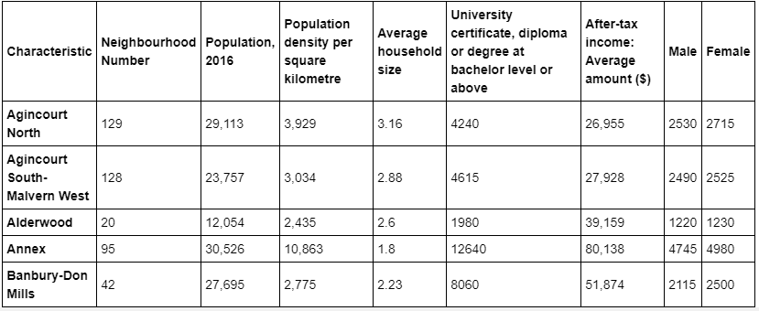

*Wikipedia data - neighborhoods with boroughs:*

1. [Wikipedia page](https://en.wikipedia.org/wiki/List_of_city-designated_neighbourhoods_in_Toronto) for Toronto Neighborhood Borough Designations is scraped using BeautifulSoup.  
2. Scraped data is transformed to dataframe.

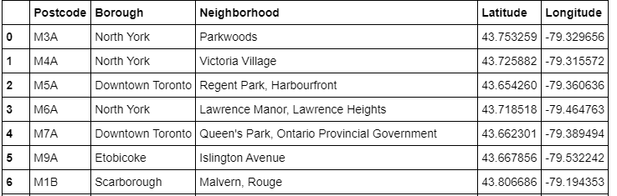

*Pull Toronto shape file:*

1. Get the [shape file](https://ckan0.cf.opendata.inter.sandbox-toronto.ca/download_resource/1d02b0f0-d735-4469-8f71-ea6d96b319e4?format=csv&projection=4326).  
2. Remove unnecessary data and merge to previous dataframe.

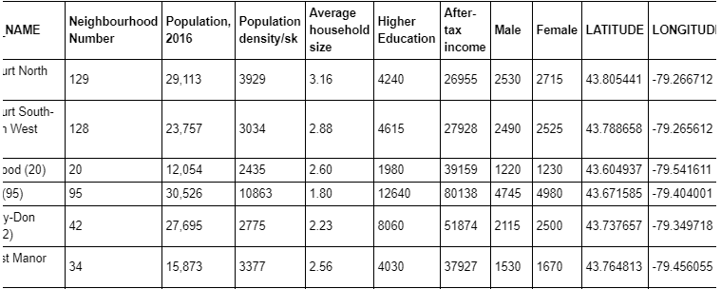

*Map of Toronto Neighborhoods:*

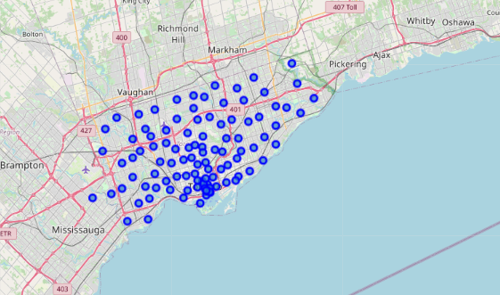

*Using Foursquare API to analyze Neighborhoods in Downtown Toronto and Etobicoke*

*1) # of venues in each neighborhood:*

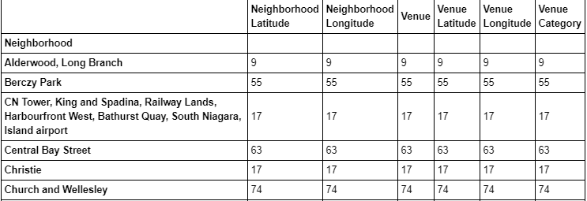

*2)Most common venues*

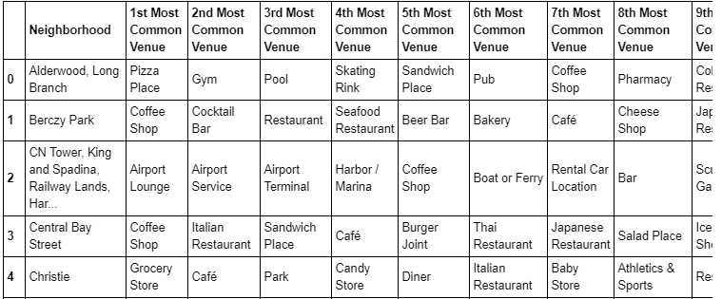

## Results and Discussion section

*1) Clustering the Neighborhoods;*

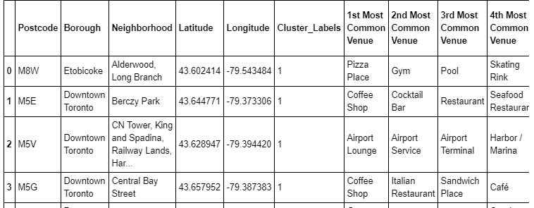

2) Census Data:

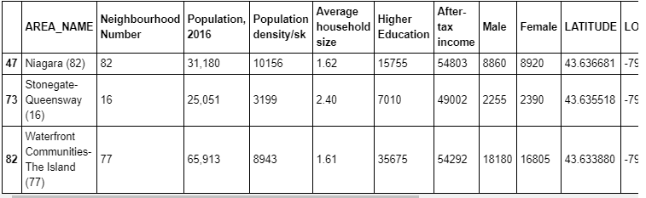

First, even though most of the neighborhoods in Etobicoke are in the same cluster as of neighborhoods in Downtown Toronto, the venues within the two Borough are different. However, they do have same level of similarities as well.

We may discuss our results under below main perspectives.

First, most common venues in Downtown Toronto are cafes and restaurants and Parks. Parks and restaurants are also a common venue in Etobicoke area.

Second, although restaurant is a common venue in both Borough, the cuisines might be very different, and further research need to be done on that. On the other hand, Etobicoke area has some hardware stores that Downtown doesn't have.

## Conclusion

To sum up, the analysis above would support my moving decision from Etobicoke to Downtown Toronto.

From the population census perspective, Downtown Toronto has far more people with higher education, and more young people from age 25 to 40. The household income in Downtown is also a lot higher than in Etobicoke. However, the overall population in Downtown is higher than Etobicoke, so I may feel crowd if moving to Downtown.

From the venue’s perspective, Downtown has more cafes and restaurants than the area I live.

Overall, Downtown is more suitable for young professionals or people looking for more social life and likes the busy part of the city.